COMMON CONVERSATIONS

INTRODUCING YOURSELF

Greetings

Hi, what is your name?
Hi, I'm Edward. Nice to meet you.
Hi, I'm Elaine. Nice to meet you, too.

What is your first name?
My first name is Edward.
I´m Edward.
My friends call me Edward.

What is your last name?
My last name is Jablonski.
My surname is Jablonski.

Do you have a nickname?
My nickname is Duducho.
No, I don´t.

Where are you from?
I am from Porto Alegre.
I was born in Porto Alegre,

Where do you live?
I live in Santo Antônio.

Good morning - 9:00 to 12:00 a.m.
Good afternoon - 12:00 to 5:00 p.m.
Good evening. – 5 p.m. to 8 p.m.
Good night.

1.2 BYE

See you.
See you tomorrow.
See you soon.
See you later.
Bye

TO BE WITH NAMES

I am
Your are
He is
She is
It is
We are
You are
They are

Who am I?
You are Edward.
Who are you?
I am …
Who is he?
He is…
Who is she?
She is …
Who are e?
We are
Who are they?
They are

To Be

Affirmative Negative Interrogative

I am a teacher. I'm not a student. Am I a teacher?
You are a student. You aren't a teacher. Are you a student?

Conversation

Are you gremista? Yes, I am. / No, I'm not.
Are you in the classroom?
Are you happy?
Are you a girl?
Are you a boy?

Affirmative Negative Interrogative

He is a bog. He isn't a man. Is he a kid?
She is a girl. She isn't a woman. Is she a man?

THE Alphabet

A, B, C, D, E, F, G, H, I, J, K, L, M, N, O, P, Q, R, S, T, U, V, W, X, Y, Z.

How do you spell your name?
It´s E-D-W-A-R-D.

Black, white, orange, yellow, brown, pink, blue, red, green, gray.

COLOR

What´s your favorite color?
My favorite color is pink.
I prefer black.
I like white.
I don´t have a favorite color.
I like any color.

Do you like soccer?
Yes, I do.
No, I don’t.

Do you watch a soccer match?
Yes, I do.
No, I don’t.

What sport do you like?
I like martial arts.

Do you prefer blue or red?
I like blue, because I cheer for Grêmio.
I prefer red, because I cheer for Internacional.

What color is better to use in clothes?
I like black.
I wear yellow.
I use purple.
I use all colors.

What color do you like to watch in a woman/man?
I think a woman gets better with red.
I like a woman with white.
I prefer a woman with black.
I like a woman in all situations.

What about cars?
I have a white car.
I would like to buy a red car.
All colors are good for cars.

Numbers 1-10

1 one, 2 two, three 3, four 4, five 5, six 6, seven 7, eight 8, nine 9, ten 10.

Tree, free, three

What is your address?
My address is Luiz de Miranda street.
I live at 945 Luiz de Miranda street.

What is your phone number?
My phone number is 9327…
It´s 9307…

FATHER

What is your father´s name?
My dad is Edward.
My father is Edward.
My father´s name is Edward.
I don´t know.

How old is he?
He is 67 years old.

What is his occupation?
He works.
He doesn´t do anything.
He is a retired man.
He is a Mechanical.

Do you have a hobby?
Yes, I do.
No, I don’t.

What is your hobby exactly?
I read books.
I write books.
I practice sports.
I dance ballet.
I play soccer.
I play games.
I go to the gym.

What do you do in your spare time?
I watch television.
I go to the movies.
I go out with my friends.
I sleep.
I play games.
I go to the gym.
I play soccer.

Does he have any hobby?
Yes, he does.
No, he doesn´t.

What kind of hobby is it?
He goes fishing.
He goes surfing.
He plays soccer.
He watches soccer matches.

What present will you buy for him?
I will buy some socks.
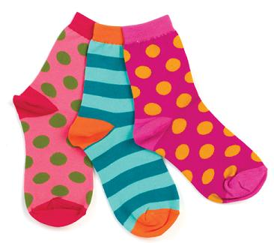
Some socks
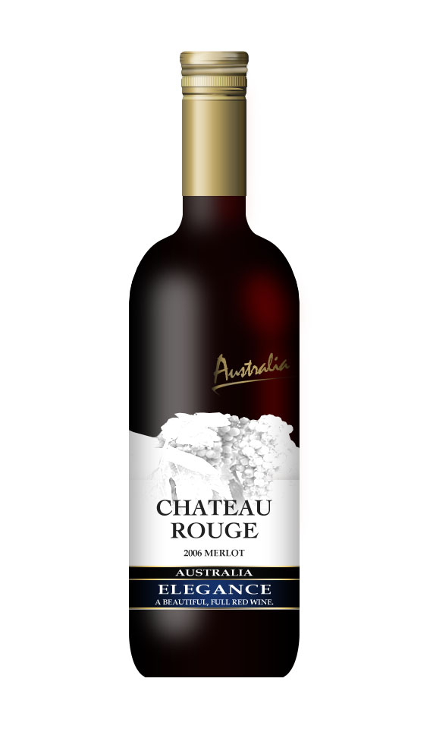
a wine bottle

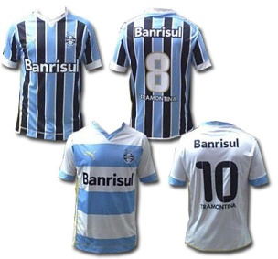
a jersey

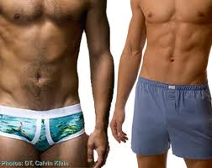
some briefs


a mug

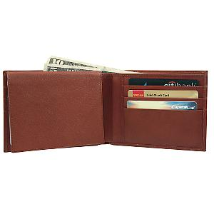
a wallet
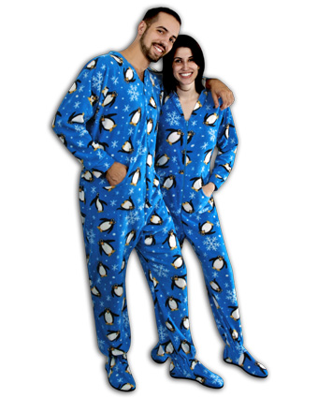

pajamas

a photo frame
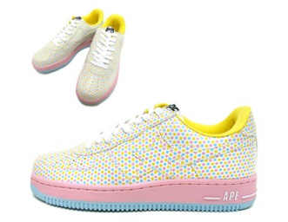
some sneakers

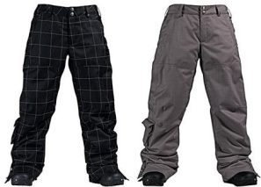
some pants

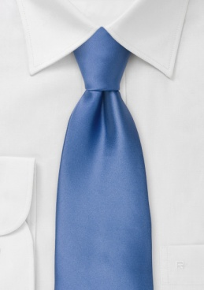
a tie

I don´t know yet.
I will not buy anything.
He doesn´t deserve.

TRANSPORTATION

How do you go to your college?
I go by bus.
I go by car.

I go on foot.

Where do you live (say the neighborhood)?
I live at Red Mud.

January, February, March, April, May, June, July, August, September, October, November, December.
1st first
2nd second
3rd third
21st Twenty first
22nd Twenty second
23rd Twenty third

When were you born?
I was born on August 2nd.
I was born on March 25th.
I was born on S
September 19th.

TIME

What time is it?
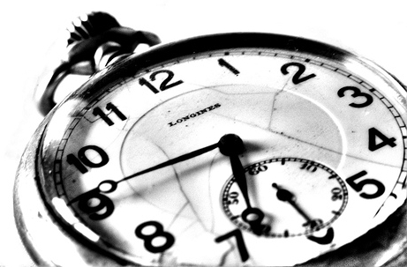
It´s a quarter to seven.

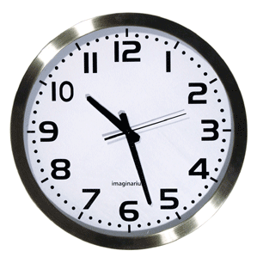
It´s ten twenty-seven.

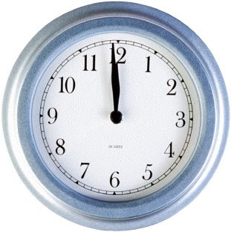
It´s noon.

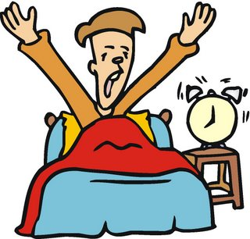
What time do you wake up?
I wake up at fifteen to six.

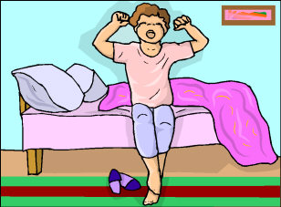
What time do you get up?
I get up at six o´clock.

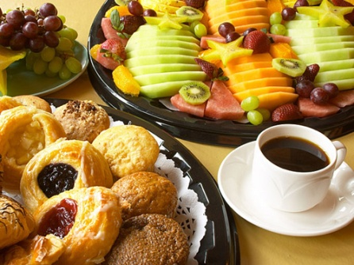
What time do you have breakfast?
I have breakfast at six twenty.
I don´t have breakfast.

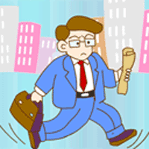
What time do you go to work \ college?
I go to work \ college at six and a half.
I go to work \ college at six thirty.

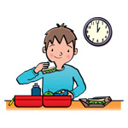
What time do you have lunch?
I have lunch at noon.

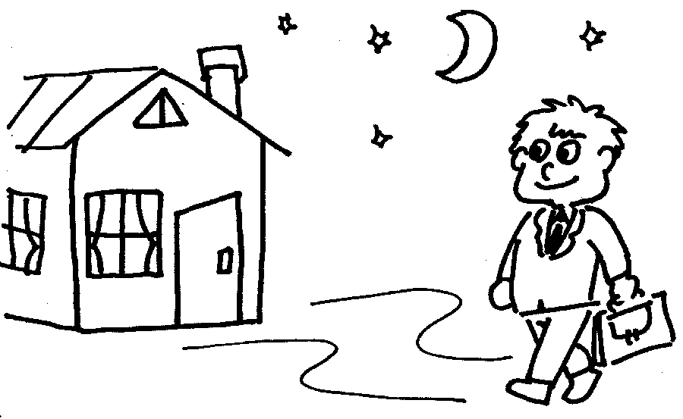
What time do you come back home?
I come back home at seven ten.
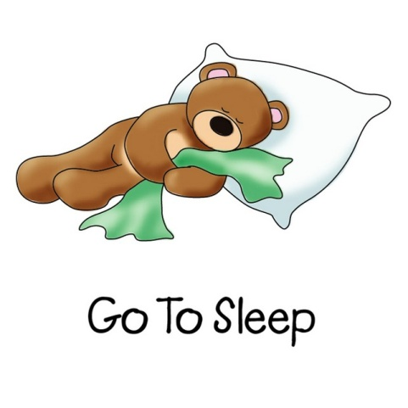
What time do you go to bed?
I go to bed at midnight.

HOW OFTEN

Every day
Once a week
Twice a week
Three times a week
Four times a week
Frequently
Sometimes
Never

Tell me an activity you do every day?
I work every day.
I sleep every day.
I go to a restaurant every day.
I go to the gym every day.
I study every day.
I pump iron every day.
I see my girlfriend/boyfriend every day.
I play with my children every day.
I watch TV every day.

Tell me an activity you do sometimes?
Sometimes I run in the park.
Sometimes I go dancing.
Sometimes I go to the movies.
Sometimes I go to restaurants.

Tell me an activity you never do?
I never wash my car.
I never watch soap operas.
I never make gossips.

How often do you go to the movies?
I go to the movies sometimes.

Do you watch movies in the cinema or at home?
I watch movies at home.
I like to go to a shopping center.

Which one?
I like Iguatemi.

What kind of movies do you prefer? (action, adventures, comedies, terror, thriller, romantic)
I love adventures movies.

How often do you listen to the radio?
I listen to the radio every day.

What part of the day do you listen to the radio? (in the morning, in the afternoon, in the evening, at night)
I listen to the radio in the morning, before I go to work.

Do you prefer music or news?
I only listen to news.

What´s your favorite singer?
My favorite singer is Vitor Ramil.
I like Os Replicantes.

What kind of music do you like?
I prefer rock or blues.

How often do you drink coffee?
I drink coffee every day.
I don´t drink coffee.

When do you use the internet?
I use the internet at night.
I use the internet at the college.

How often do you eat meat?
I eat meat three times a week.
I eat meat every day.
I don´t eat meat, because I´m a vegetarian guy.

Picture | English
 | Aerobics
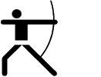 | Archery
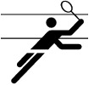 | badminton
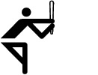 | baseball
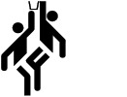 | basketball
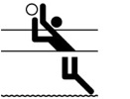 | beach volleyball
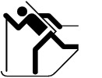 | biathlon
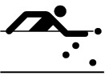 | billiards
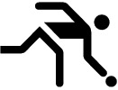 | bowling  skittles
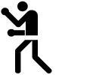 | boxing
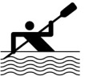 | canoeing
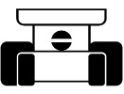 | car racing
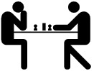 | chess
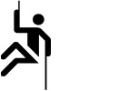 | climbing
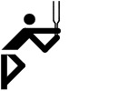 | cricket
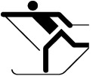 | cross-country skiing  (also: langlauf)
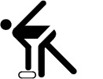 | curling
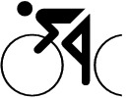 | cycling
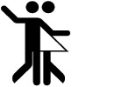 | dancing
 | darts
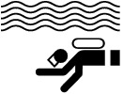 | diving
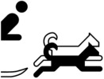 | dog-sledging
 | downhill
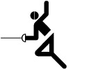 | fencing
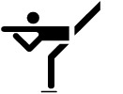 | figure skating
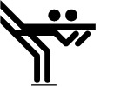 | figure skating (pairs)
 | fishing
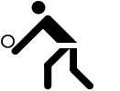 | fist ball
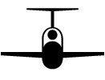 | gliding
 | golf
 | gymnastics
 | handball
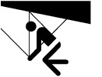 | hang gliding
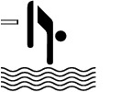 | high diving
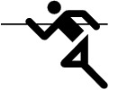 | high jump
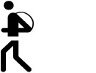 | hiking
 | hockey
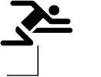 | hurdle race
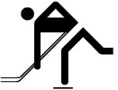 | ice hockey
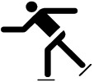 | ice skaing
 | in-line skating
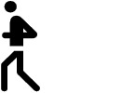 | jogging
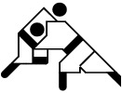 | Judô
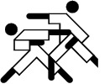 | Karate

Do you play any sport?
Yes, I do.
No, I don´t.

What sports do you play?
I don´t play any sport.
I don´t like sports.
I don´t have time to play any sport.
I play soccer / volley.
I go swimming.
I go surfing.
I pump iron, and practice martial arts.

How often do you exercise?
I exercise every day.
I don´t exercise.
I exercise sometimes.

What languages do you speak?
I speak a little English.
I speak English and Portuguese.
I don´t speak any foreign language.

What TV show do you watch?
I watch soccer matches.
I prefer soap opera.
I like movies.
I prefer talk shows,
I watch comedies.
I like romantic movies.
I prefer action movies.

What TV show do you hate?
I hate soap opera.
I dislike Ratinho.
I don´t like music concerts.

How many hours do you spend watching TV?
I spend three hours a day.
I don´t watch TV.

What can you do?
I can develop a software.
I can speak in English.
I can play the guitar.

What can´t you do?
I can´t cook well.
I can´t dance.
I can´t make friends.

What´s your favorite day of the week? (Sunday, Monday, Tuesday, Wednesday, Thursday, Friday, Saturday)
I prefer Saturday, because I stay with my girlfriend/boyfriend.
I like Friday, because the other day I don´t work.

Where do you have lunch?
I have lunch at home.
I go to a restaurant.
I have lunch in my job.

READING


CONVERSATION

Do you like to read?
Yes, I do.
No, I don´t.

How many books do you read in a year?
I read one book in a year.
I read two books in a year.
I read more than ten books in a year.
I don´t read any book.

What do you prefer: a book, a magazine, a newspaper or sites?
I prefer books.
I like sites.
I don´t like to read.

When you take a newspaper, what section do you go first?
I go first to politics, sports, health, books, business, computing science, jobs.
I never take a newspaper.
I never read a newspaper.
I read comics.

SHARE

Do you share your room?
Yes, I do.
I share my room with my wife and my kids.
No, I don´t.

Do you share your things?
Yes, I do. Why not?
No, I feel jealous about them.
I only lend books.

Are you an only child?
Yes, I am.
No, I´m not.

Would you like to have a brother or a sister?
Yes, so I would have a friend.
No, I prefer to be an only child.

Do you have a single bed or a double bed?
I have a double bed.
I have a single bed.

VACATION

When do you go on vacation?
I go on vacation in January.

Where do you go to?
I go to the mountains.
I go to the beach.
I stay at home.

What do you do when you are on vacation?
I walk.
I have baths in the sea.
I play soccer / volley.
I take some rest.
I play games.
I read books.

What magazines do you read?
I don´t like to read.
I read Veja.
I only read web sites.

How many days do you take?
I take twenty days, and sell ten.
I take thirty days.
I take only a week.

Do you like to go on vacation in the winter?
Yes, I do.
No, I don´t.

FOOD

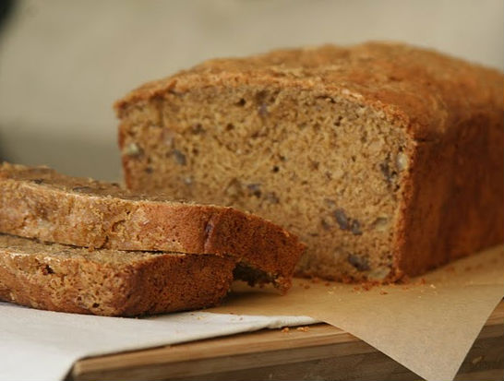
Bread,

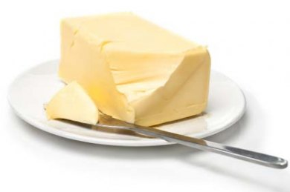
butter,

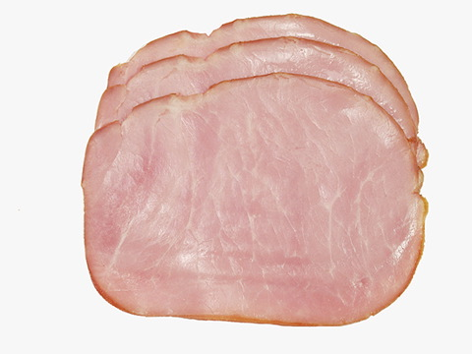

ham,

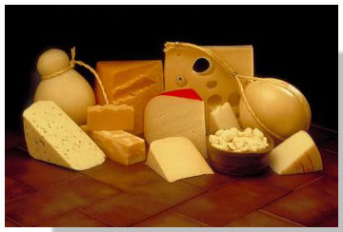
cheese,

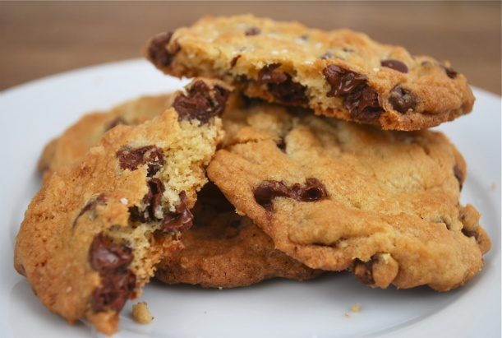

cookies,

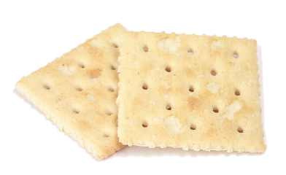
cracker,
sandwich,

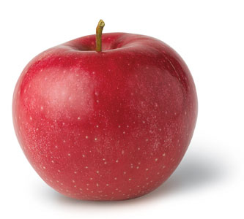
Apple,
orange,
banana,
Coffee,

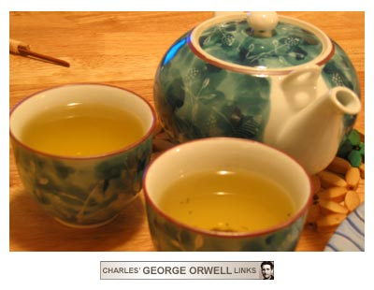
tea,


milk,

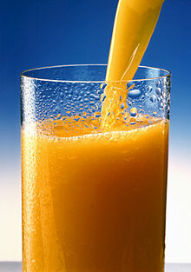
juice,
Tomato,

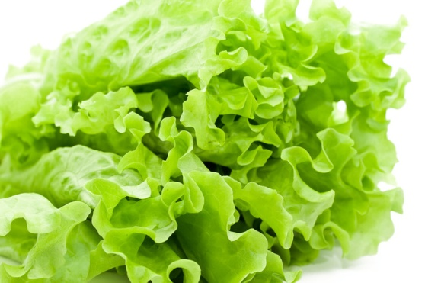
lettuce,

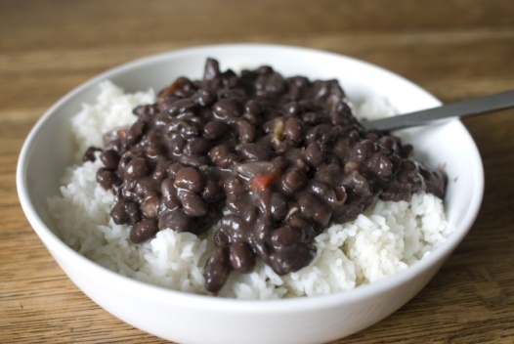
rice and beans
beef,
chicken,
pasta,
potato salad,
salad.

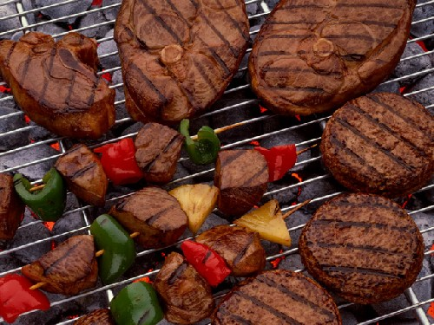
Barbecue,

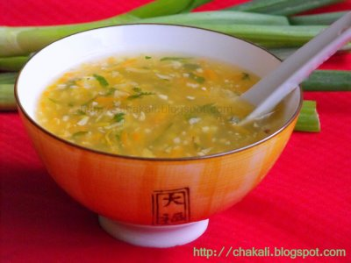
soup

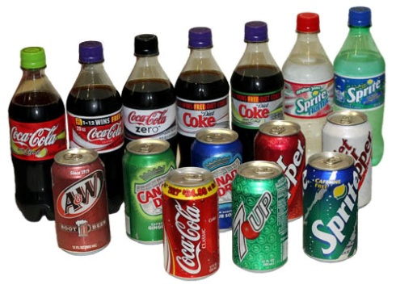
Soda, soft drink, pop, coke

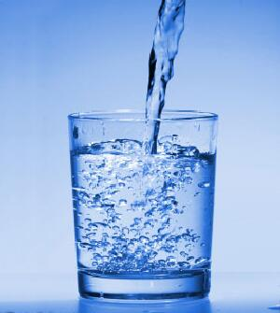
water.

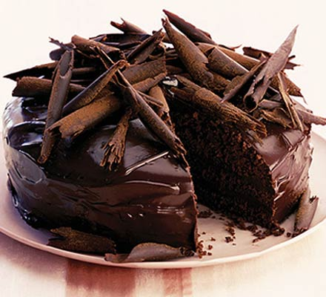
Chocolate cake,

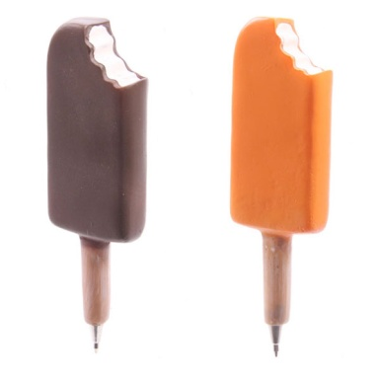
Lolly ice cream

ice cream

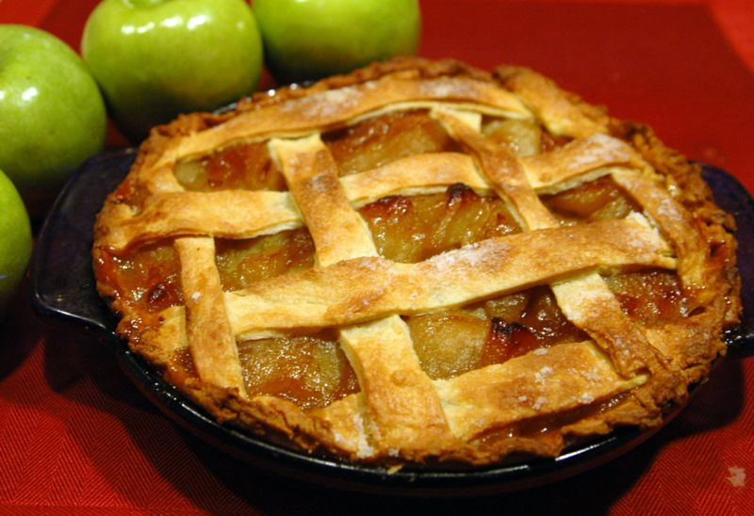
apple pie;

Meat
Beef
Pork
Chicken
Bacon
Ham
Liver
Turkey
Duck
Sausages
Salami
Patê

How often do you eat meat?
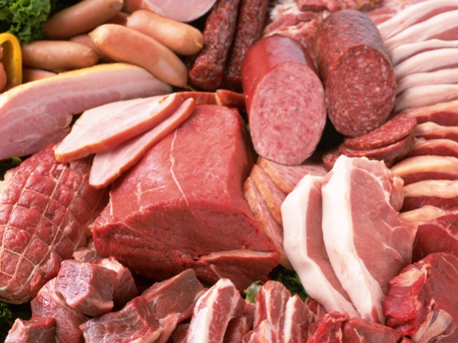

I eat meat every day.
I eat meat three times a week.
I eat meat on the weekend.
I don´t eat meat.

What kind of meat do you like?
I like pork.

What kind of meat do you hate?
I hate liver.

Do you eat any of these meats in a special situation?
Yes, I eat turkey at Christmas party.
Yes, I eat barbecue on September 6th.

Dairy products
Milk, Bread
Eggs, ham
Butter, pie
Margarine, sandwich
Cream, coffee, tea
Cheese
Yoghurt

What do you have for breakfast?
I drink coffee or juice.
I eat a sandwich.
I eat bread, and drink coffee.
I don´t have anything.

What do you have for lunch?
I have rice and beans, chicken, and salad.
I drink tea / soda.
I go to a vegetarian Chinese restaurant.
I have barbecue.

What do you have as a snack?
I usually eat some cookies / cracker / a sandwich / a hot sandwich / fruits / cereal bar.

What do you have for dinner?
I usually have a hot sandwich or soup.
I don´t have dinner.

What´s your favorite dish?
I love lasagna with shrimp and cheese.
My favorite dish is sweets.
I like sweets.
I like French fries.
I love pizza.

How much fruit do you eat a day?
I don´t eat fruits.
I eat at least one fruit a day.

How many vegetables do you eat every day?
I don´t eat vegetables.
I eat a little.

How much water do you drink?
I drink at least one liter a day.
I drink one glass a day.
I don´t drink water.
I drink only soft drink.

CONVERSATION ABOUT JOB

Where do you work?
I work for QI.

Where does your company stay?
It stays in Porto Alegre.

What exactly do you do?
I develop software.

How long have you worked for your company?
I have worker for eight years.

THERE IS/ THERE ARE

How many TVs are there in your house?
There are three.

Is there a computer in your bedroom?
Yes, there is.
No, there isn´t.

How many students are there in this class?
There are five.

How many teachers are there here?
There is one.

BANKS

What bank do you have a bank account in?
I have a bank account in two banks: Banrisul and Itaú.

What time do banks open in your country?
They open at 10 o´clock.

Do you usually have to wait a lot when you go to the bank?
Yes, a lot.
Not so much.

HOW FAR

How far is your house from the school?
It´s more or less five kilometers.

How far is your house from the beach?
It´s more or less thirty kilometers.

SCHOOL

What school do you study?
I study in Patrulhense.

Do you like your school?
Yes, I do.
No, I don’t.

Why?
Because the teachers are boring.

PRESENT CONTINUOUS

What are you doing now?
I am studying English.

What is your best friend doing now?
I think he/she is watching TV.
I think he/she is studying.
I think he/she is sleeping.

What are you going to do this weekend?
I am going to visit my grandmother.
I am going to the movies.
I am going to go out with my friends.

CLOTHES

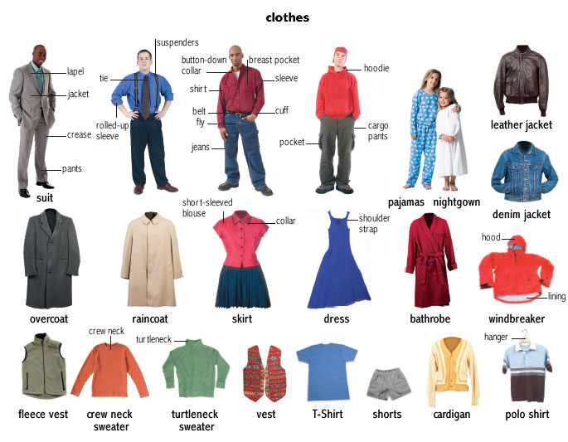

SHOES
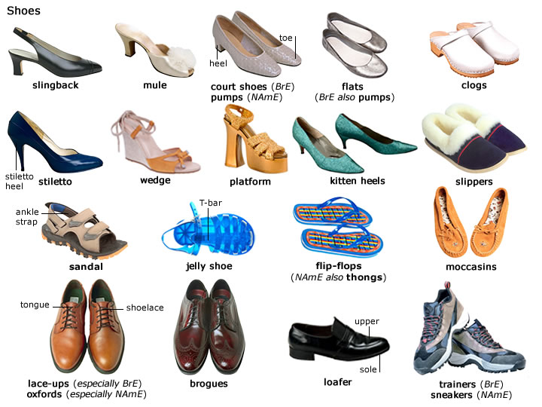

What are you wearing today?
I am wearing pants and a t-shirt, with some sneakers.

What do you wear when you are at home?
I usually wear shorts, t-shirt and flip-flops.

What are you going to do next vacation?
I am going to go to Japan.
I am going to stay at home.

When are you going to get married?
I don’t know yet.
I am already married.

What are you going to do tonight?
I am going to the college.
I am going watch a movie.
I am going to sleep.
I am going to take some rest.

Numbers 11-30

eleven 11, twelve 12, thirteen 13, fourteen 14, fifteen 15, sixteen 16, seventeen 17, eighteen 18, nineteen 19, twenty 20. twenty-one 21, twenty-two 22, twenty-three 23, twenty-four 24, twenty-five 25, twenty-six 26, twenty-seven 27, twenty-eight 28, twenty-nine 29, thirty 30.

How old are you?
I am 45 years old.

More numbers

forty 40, fifty 50, sixty 60, seventy 70, eighty 80, ninety 90, one hundred.

Parents

My father is Eduardo. My mother is Sonia. Then my parents are Eduardo and Sonia.
My father is dead. My mother is 60 years old. She is from Rio Grande.

How old is your father?
He is sixty seven years old.

How old is your mother?
She is sixty eight years old.

Where is he from?
He is from Guarani das Missões.

Where is she from?
She is from Rio Grande.

Pronouns: my, your, his, her, its, our, their.

What's your name? My name is ...

What's my name? Your names is ...
What's his name? His name is ...
What's her name? Her name is ...
What's its name? Its name is ...
What are our names? Our names are ...
What are their names? Their names are ...

Do

Affirmative Negative Interrogative

I do my homework. I don't do my task. Do I do my activity?
She does her chores. She doesn't do her meal. Does she do her complaint?
He does his task. He doesn't do his breakfast. Does he do his text?

Have

Affirmative Negative Interrogative

I have a car. I don't have a house. Do I have an apartament?
She has a bike. She doesn't have a laptop. Does she have a ring?

Prepositions in, at, on.

In

Where is your book?
The book is in the backpack.

Where do you live?
I live in Santo Antônio, in Rio Grande do Sul, in Brazil.

What do you do in the morning?
In the morning, I have breakfast.

What do you do in the afternoon?
In the afternoon, I teach English.

What do you do in the evening?
In the evening, my friend has a drink.

What do you do in the summer?
In the summer, I go to the beach.

What do you wear in the winter?
In the winter, I wear a sweater.

What do you wear in the fall?
In the fall, I wear a t-shirt.

What do you see in the spring?
In the spring, I see beautiful flowers.

Which month and year were you born?
I was born in August, in 1969.

At

What do you usually do at Christmas?
I go to the house of my mother.

What do you usually do at Easter?
I buy chocolates to my daughter, to my son, and to my wife.

What do you usually do at Carnival?
I rent lots of movies.

What do you do at bus station?
I observe pretty women.

Which subject do you like the most at school?
I like English.

Tell me one thing you do at home? I play with my daughter.
Tell me one thing you do at home.

What time do you go to bed?
I go to bed at 11 o'clock p.m.

Where do you live?
I live at 945 Luiz de Miranda Street.

Which neighborhood do you live at?
I live at Red Mud.

On

Which day were you born?
I was born on August 2nd.

What do you do on Saturday?
I practice Karate.

Which street do you live on?
I live on Luiz de Miranda Street.

Where is your pen?
My pen is on the table.

JOBS

Musician, doctor, gardener, electrician, photographer, salesperson, cook, repairperson, bricklayer, receptionist, painter, police officer, security guard, lawyer, pilot, postman, singer, locksmith, firefighter.

Who serves passengers?
A flight attendant servers passengers.

Conversation

Who plays musical instruments?
Who takes care of sick people?
Who waters plants?
Who repairs electrical equipments?
Who prepares meals?
Who takes pictures?
Who sells goods?
Who deliver letters?
Who repairs objects?
Who answer the phone?
Who guards a bank?
Who makes and fixes locks?
Who puts out fire?
Who defends accused people in court?
Who flies a plane?
Who preserves the order?
Who builds walls with bricks?
Who paints pictures?
Who sings songs.

VERBS

To drink, to play, to watch, to go out, to drive, to take a shower, to read, to write, to get up, to call, to eat, to leave.

What do you drink?
I drink water, coffee and juice.

Which games do you play?
I play cards.

Which TV show do you watch?
I watch soccer matches.

Where do you go when you go out?
I go to the movies.

What time do you take a shower?
I take a shower at 6:00.

Who

Who do you play soccer with?
I play soccer with my friends.

Who plays volleyball on the weekend?
My cousin plays volleyball on the weekend.

Who is your best friend?
Fernanda is my best friend.

Adverbs: usually, often, seldom

What do you usually do?
I usually read books.

What do you often do?
I often practice martial arts.

What do you seldom do?
I seldom listen to music.

Means of Transportation

Transportation: bus, subway, train, ferry-boat, taxi, plane, ship/boat, car, bicycle, motorcycle, on foot.
Place: bus station, bus stop, subway station, train station, ferry terminal, taxi stand, airport, harbor.

Where do you take a taxi?
I take a taxi at a taxi stand.

How do you go to work?
I go to work by bus/ by car / by motorcycle, on foot.

What, who, where, when, how, why

What do you do?
I work.
I study.

Who is the most beautiful kid in the world?
Fernanda is the most beautiful kid in the world.

Where do you live?
I live in Santo Antônio.

When do you go to the beach? I go to the beach in the summer.

How are you?
I’m fine.
So so.

Why do you study English?
I study English because I want to travel.

Bring and Take

I'll bring a cup of tea to you.
I'll take your cup to the kitchen.

Can you bring a pen to me?
Yes, I can. / No, I can´t.

Can you take my book to the library?
Yes, I can. / No, I can´t.

BAD HABITS

Do you have any bad habits?
Yes, I do.
I smoke.
I drink beer.
I sleep a lot.
I don´t study.
I am aggressive to people.
I have lovers.

Do you know anyone who bites his or her nails?
Yes, I do.
No, I don´t.

Do you know anyone who has a very annoying habit?
Yes, I do. My brother.
He smokes.
He drinks beer.
He sleeps a lot.
He doesn´t study.
He is aggressive to people.
He has lovers.

What are some good habits to have?
To read books.
To eat vegetables and fruits.
To drink water and juice.
To practice sports.
To get along with people.

Do you have good study habits?
Yes, I do.
I read books.
I read magazines.

Is there anyone whose work or study habits you admire?
Yes, I admire people who study a lot.

How can people break bad habits?
I think people must have great emotional strength.

How do we learn our habits?
I suppose we have to force a habit until it becomes our routine.

Describe a very unusual habit you have observed in someone?
I know a person who writes books.
I know a person who studies lots of languages.
I know a person who reads a book per week.

